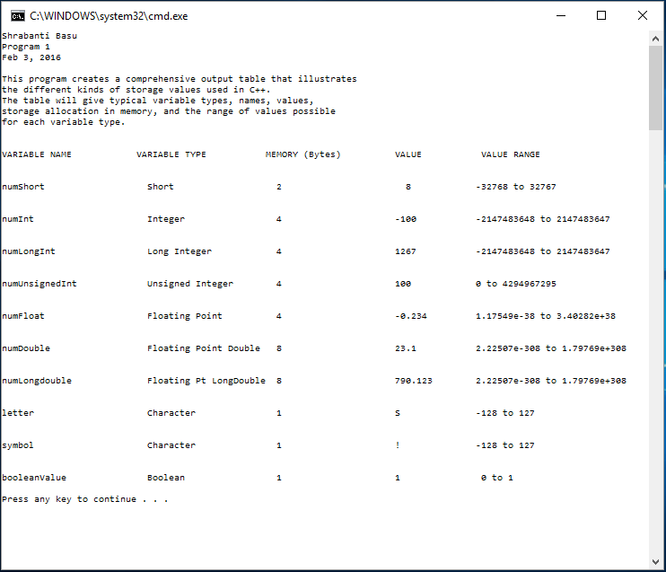

//Shrabanti Basu

//Program 1

//Feb 3, 2016

/*

This program lists different kinds of storage values that can be used in C++.

The program gives variable names, types, storage allocation in memory, values,

and the range of values possible for each variable type.

*/

#include <iostream>

#include <cfloat>

using namespace std;

int main()

{

cout << "Shrabanti Basu\n";

cout << "Program 1\n";

cout << "Feb 3, 2016\n\n";

cout << "This program creates a comprehensive output table that illustrates\n";

cout << "the different kinds of storage values used in C++.\n";

cout << "The table will give typical variable types, names, values,\n";

cout << "storage allocation in memory, and the range of values possible\n";

cout << "for each variable type.\n\n\n";

/*Declare nine different types of variables with appropriate names and

assign an appropriate value to each variable.

For char type, use both a character and an ASCII value.

*/

short numShort = 8;

int numInt = -100;

long int numLongInt = 1267L;

unsigned int numUnsignedInt = 100;

float numFloat = -0.234F;

double numDouble = 23.10;

long double numLongDouble = 790.123L;

char letter = 'S';

char symbol = 33;

bool booleanValue = true;

cout << "VARIABLE NAME \t\t VARIABLE TYPE \t\t MEMORY (Bytes) \t VALUE \t\t VALUE RANGE\n\n\n";

cout << "numShort \t\t Short \t\t " << sizeof(short) << "\t\t\t "

<< numShort << "\t\t" << SHRT_MIN << " to " << SHRT_MAX << "\n\n\n";

cout << "numInt\t\t\t Integer \t\t " << sizeof(int) << "\t\t\t "

<< numInt << "\t\t" << INT_MIN << " to " << INT_MAX << "\n\n\n";

cout << "numLongInt\t\t Long Integer \t " << sizeof(long int)

<< "\t\t\t " << numLongInt << "\t\t" << LONG_MIN << " to "

<< LONG_MAX << "\n\n\n";

cout << "numUnsignedInt\t\t Unsigned Integer \t " << sizeof(unsigned int)

<< "\t\t\t " << numUnsignedInt << "\t\t" << "0 to " << UINT_MAX << "\n\n\n";

cout << "numFloat\t\t Floating Point \t " << sizeof(float) << "\t\t\t "

<< numFloat << "\t\t" << FLT_MIN << " to " << FLT_MAX << "\n\n\n";

cout << "numDouble\t\t Floating Point Double " << sizeof(double) << "\t\t\t "

<< numDouble << "\t\t" << DBL_MIN << " to " << DBL_MAX << "\n\n\n";

cout << "numLongdouble\t\t Floating Pt LongDouble " << sizeof(long double)

<< "\t\t\t " << numLongDouble << "\t" << LDBL_MIN << " to " << LDBL_MAX << "\n\n\n";

cout << "letter \t\t\t Character \t\t " << sizeof(char) << "\t\t\t "

<< letter << "\t\t" << CHAR_MIN << " to " << CHAR_MAX << "\n\n\n";

cout << "symbol \t\t\t Character \t\t " << sizeof(char) << "\t\t\t "

<< symbol << "\t\t" << CHAR_MIN << " to " << CHAR_MAX << "\n\n\n";

cout << "booleanValue \t\t Boolean \t\t " << sizeof(bool) << "\t\t\t "

<< booleanValue << "\t\t" << " 0 to 1" << "\n\n";

return 0;

}